**Assingment Solutions For Day 4**

**Solution for Question 1**

**>open command terminal in windows and type “*nslookup*”**

**>type “set type=mx”**

**>type ibm.com**

**Mail servers for** [**www.ibm.com**](http://www.ibm.com)

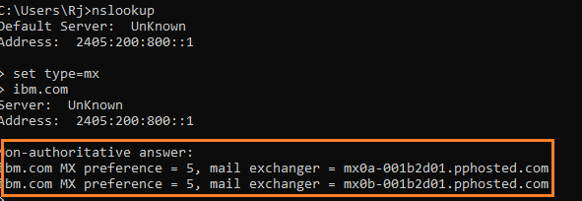

**Mail servers for** [**www.wipro.com**](http://www.wipro.com)

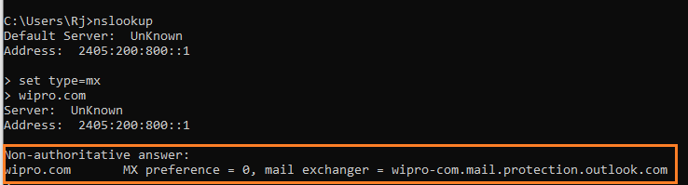

**Solution for question 2**

**Location for mail server of** [**www.wipro.com**](http://www.wipro.com)

**>just ping the mail server address in command terminal to get the ip and locate the ip addresss in any website like iplocation.net**

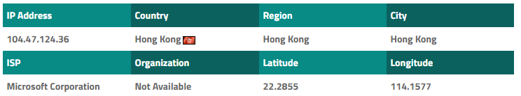

**Location for mail server** [**www.ibm.com**](http://www.ibm.com)

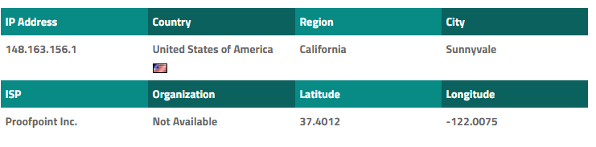

**Solution for question 3**

**>No open ports for the following ip 203.163.246.23**

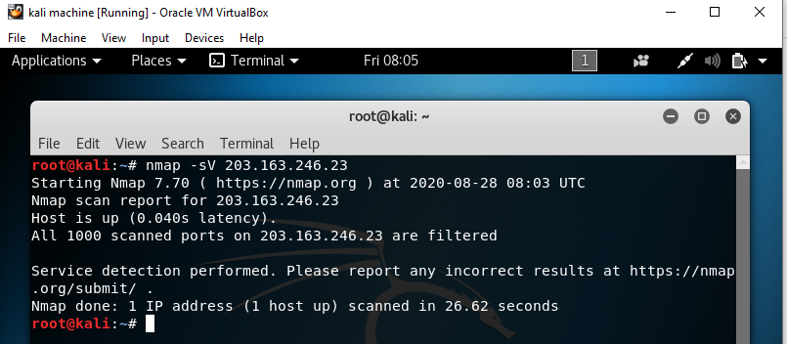

**Solution for Question 4**

**Installed Nessus in kali linux virtual machine**

**Download the Nessus from this link**

<https://www.tenable.com/downloads/nessus?loginAttempted=true>

**>Open the kali terminal and navigate this commands**

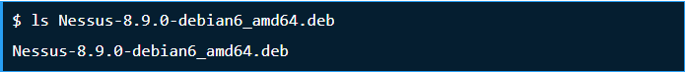

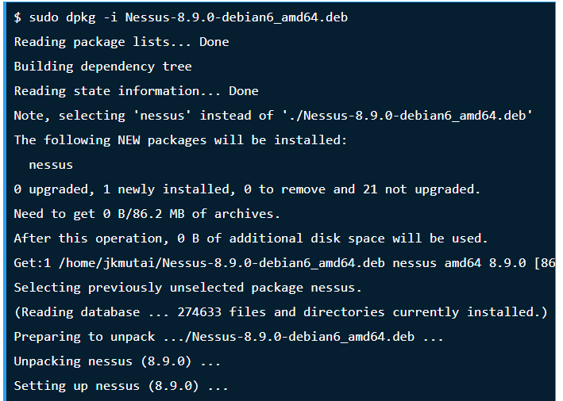

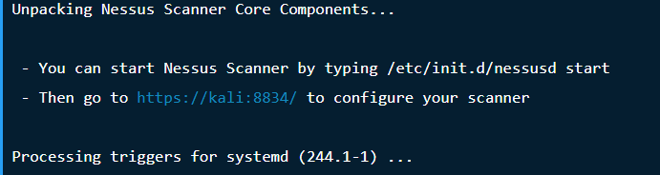

**>Navigate to** [**https://kali:8834/**](https://kali:8834/) **in web browser to configure and start Nessus**

**> Start for scanning devices**

